**Fiche de révision Project Management**

**Process groups :**

Each phase can be a project. Each project requires processes.

* Initiating
* Planning
* Executing
* Monitoring and Controlling: lasts during whole project
* Closing

**Project areas:**

Based on the PMBOK® Guide, there are 10 knowledge areas:

1. Project Integration Management

2. Project Scope Management

3. Project Time Management

4. Project Cost Management

5. Project Quality Management

6. Project Human Resource Management

7. Project Communication Management

8. Project Risk Management

9. Project Procurement Management

10.Project Stakeholder Management

All knowledge areas are controlled.

**Processes:**

Pas facile à résumer

**Summarizing slides:**

**Critical path:**

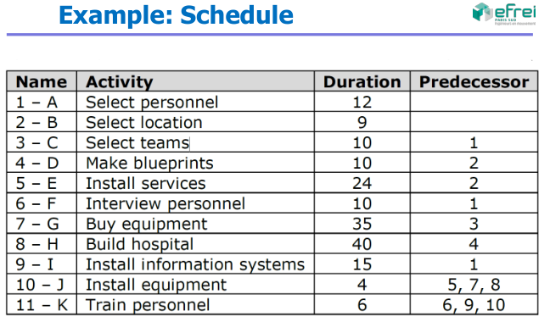

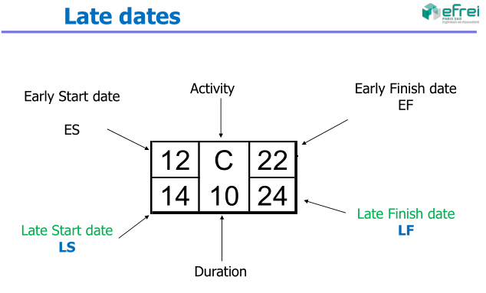

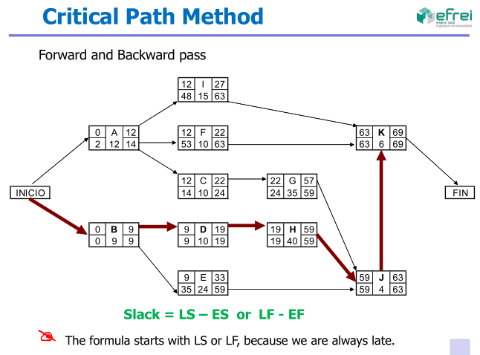

**Earned value:**

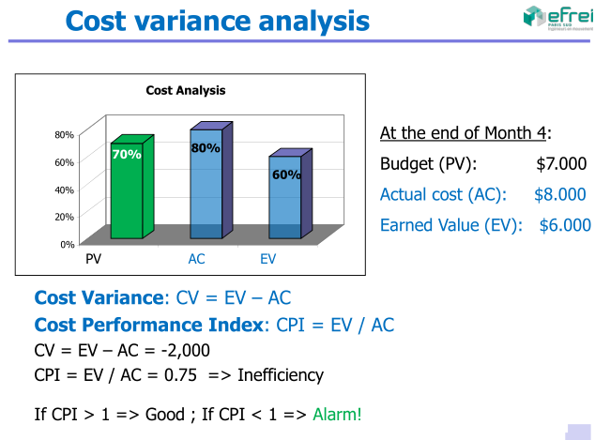

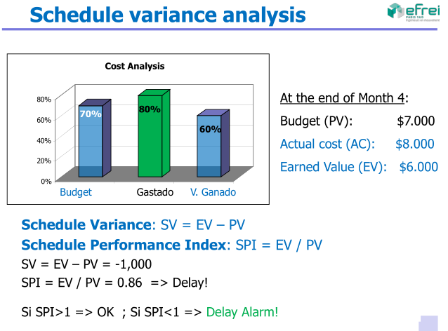

Estimation:

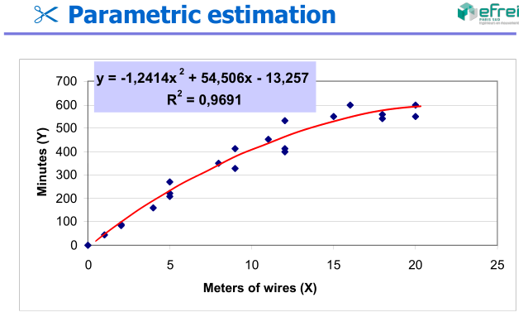

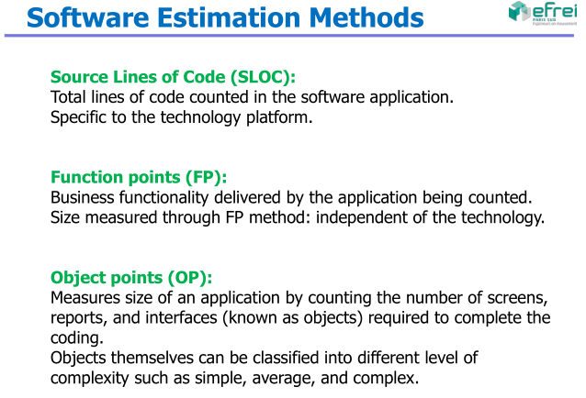

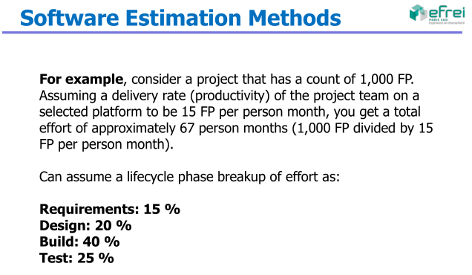

**Change request:**

??

**Quality tools:**

1. Cause-and-effect diagram: what causes problems

2. Flowcharts: what is done

3. Check sheets: recollect and organize the data

4. Histograms: graphical view of the variations

5. Pareto chart: problem ranking

6. Control charts: variations control

7. Scatter diagrams: relation between variables

**risk strategies**

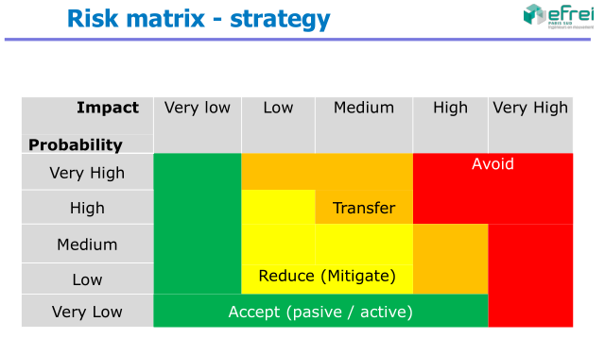

**stakeholder strategies**

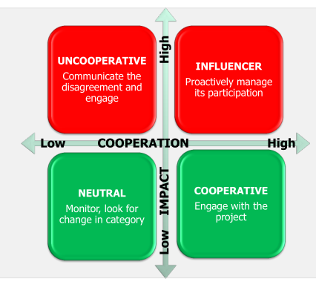

**conflict resolution**

**Causes: schedules, change of priorities, and lack of**

**resources, etc.**

- Conflict => ≠ opinions => more creativity => Good !

- Well manage => more productivity

- Address them early and in private

- Use a direct and constructive approach

- Last option => disciplinary actions

*What is the main source of conflict in projects ?*

A. Schedule

B. Priorities

C. Costs

D. Personalities

Answer:

1º Schedule, 2º Priorities, 3º Resources,

4º Technicalities, 5º Administrative processes, 6º Costs

7º LAST – Personality

*What is the most convenient way of conflict resolution?*

A. Withdraw / Avoid: step away from conflict

B. Smooth / Accommodate: emphasize on agreement areas rather than on differences

C. Compromise / Reconcile: each side should let go of something

D. Force / Direct: impose one position at the expense of others

E. Collaborate: seek different opinions to find commitment and consensus

Answer:

1º Collaborate = Conflict resolution (win-win)

2º Compromise or reconcile (lose-lose)

The worst: Force or withdraw

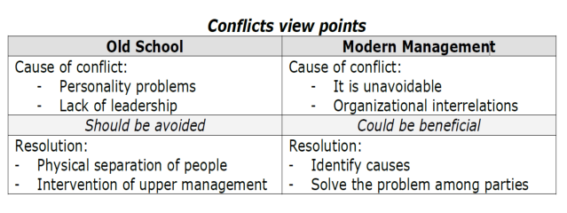

Conflict management STEPS:

1. Identify the problem root cause

2. Analyze the problem

3. Identify alternative solutions

4. Implement a decision

5. Validate if that decision solved the problem

**human resources leadership**

Types of power:

Formal – Hierarchical position in the company

Rewards – Authority to manage recompenses

Penalty – Authority to manage punishment

Expert – Based on knowledge and formation

Referred – referred by a superior

**software development**

**life cycle stages and testing**

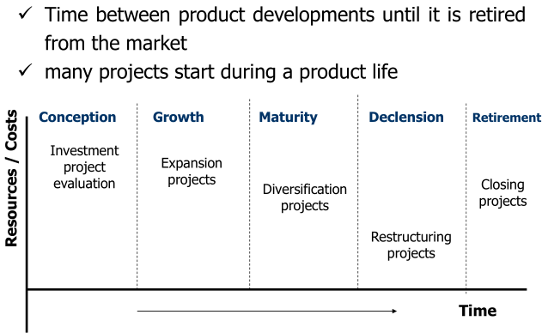

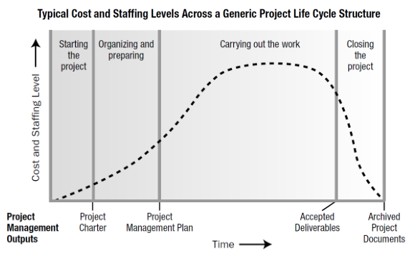

**provider selection in procurements**

Fixed-price or lump-sum

* Fixed-price (FP)
* Fixed-price-incentive-fee (FPIF)
* Fixed-price economic price adjustment (FP-EPA)

Cost-reimbursement (CR)

* Cost-plus-fixed-fee (CPFF)
* Cost-plus-incentive-fee (CPIF)
* Cost-plus-award-fee (CPAF)
* Cost-plus-percentage of cost (CPPC)

Time and materials (T&M)

They have a variable component (e.g.: amount of hours), plus a fixed component (e.g.: hourly rate)

